Use version control systems command to clone, commit, push, fetch, pull, checkout, reset, and

delete repositories.

Create A repository

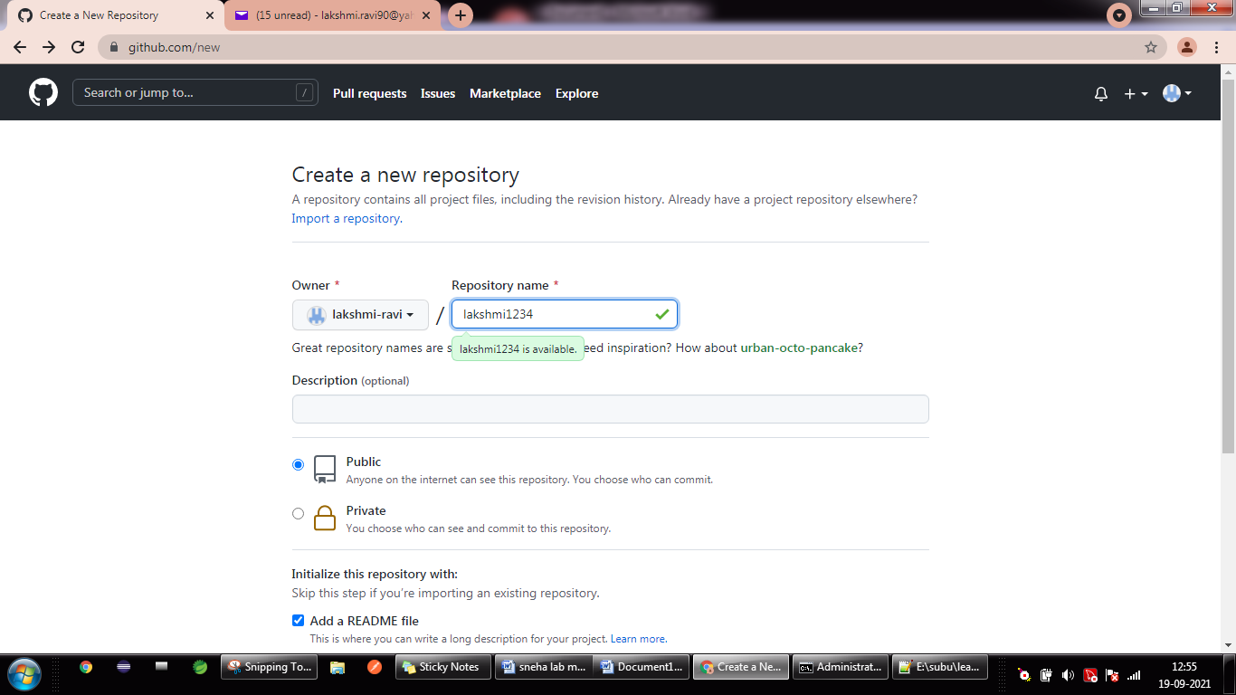

ADD A FILE:

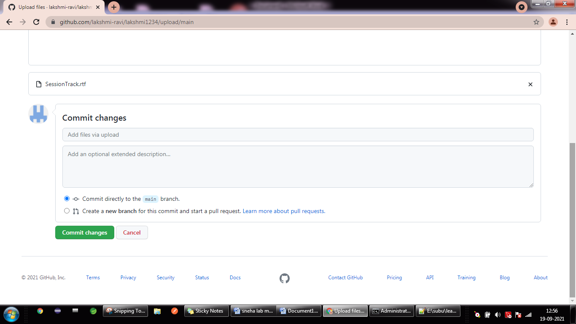

CLONE : git clone <https://github.com/lakshmi-ravi/lakshmi1234>

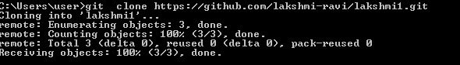

PULL COMMAND:

Before executing pull command create any file in c:/user/users/lakshmi1->sample.txt

And then execute the command

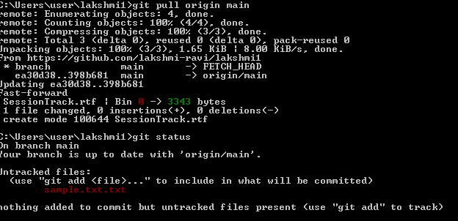

COMMIT COMMAND:TO MOVE THE FILE AVAILABE IN THE MACHINE TO REPOSITORY

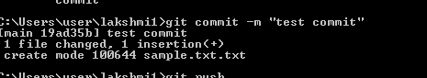

PUSH command:

